Retail Media Closed-Loop Reporting — Market Research and Report Concepts
Sep 20, 2026
Plain-language edition. Every picture of another company's report is drawn from what they say in public, because none of them publishes a real sample; real screenshots will replace the drawings. The four concept pictures are our own ideas, shown with made-up numbers for a made-up retailer (Nordmark), supplier (Aurelia Foods) and media partner (MediaBridge). A Word copy of this document is in the chat.

1. The whole story on one page
Nobody sells the report our prospects asked for. Every retailer and every software company gives suppliers a screen full of numbers, and then an account manager builds the real story by hand in PowerPoint. That hand-made deck is what our prospects showed us. Our chance is to make it a product.
Five things we found
- Nobody sells the story. Not one company in Europe or the US shows a sample of its end-of-campaign report in public. The "what did the ads really add" result is delivered as a document by the account team, often only for big spenders.
- Everyone's report has the same bones. What the ads delivered → what was sold → who bought → what the ads really added. Retailers with loyalty cards lead with one number: how much better the result looks once in-store sales are counted (Boots +22%, Carrefour +32%).
- "Not a dashboard" means "explain it and make it comparable". Agencies complain that every retailer counts differently, that "sales per euro" is not the same as "extra sales the ads caused", and that they cannot line up one retailer against another. A good story prints how it counted right next to the number.
- The rules already say what must be on the page. The European standard (IAB Europe, 2026) says: count sales for 30 days unless the client picks another window and says so; show sales from clicks and sales from views separately; say what "same brand" includes; say how "new buyer" is defined; and if you claim the ads caused extra sales, say how you know and how sure you are. Two European retailers have been audited against it so far.
- Reports are becoming live and self-writing. The newest tools write the summary sentence for you and update during the campaign, not only after it. A story that only exists at the end will look old by the time our first client renews.
What we should do: build the campaign story as a set of ready-made pages. Each page answers one question, shows one picture, starts with one plain sentence, and carries a small "how we know" note. The pages appear in a fixed order and light up one by one as the campaign moves from "registered" to "final result". One click turns the story into slides. Later, let people choose and reorder pages for their own audience.

2. What our prospects asked for
They said two things, and they are really one thing. "Follow the IAB rules" is about what the numbers must be. "Not a dashboard" is about how the numbers must be read. Both come from the same frustration: numbers nobody can compare, explained by nobody.
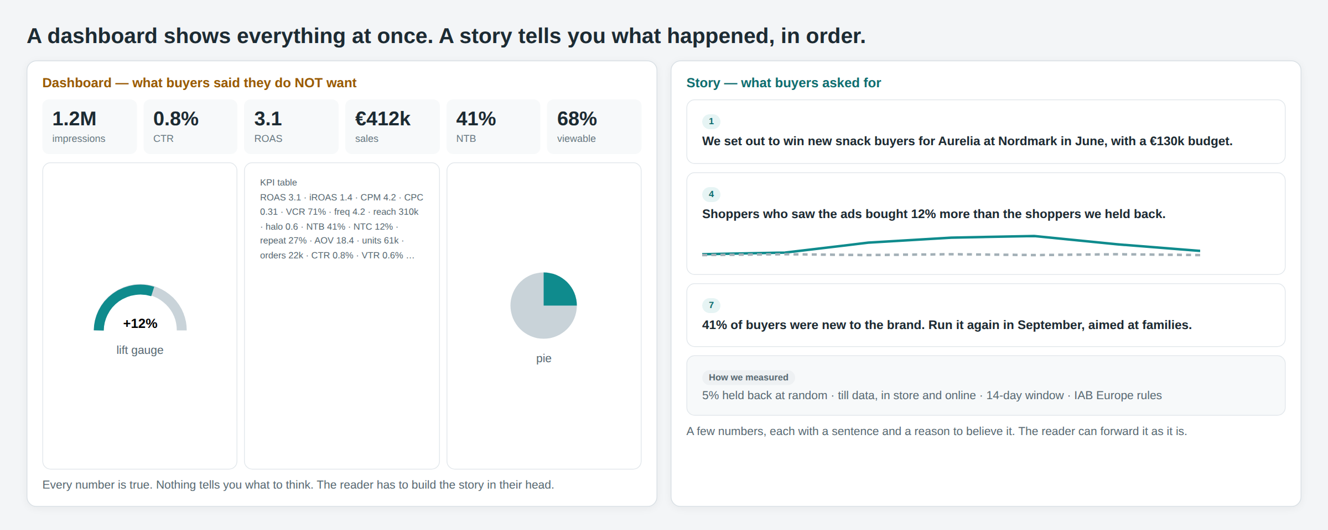
- A story has a beginning, a middle and an end. The sample deck we received walks through the campaign from launch to result. Every good end-of-campaign report we found does the same: what we set out to do, what happened, what it was worth, what to do next. A dashboard has no order; it shows the state of everything, right now.
- One message per page. The best business-reporting rules say every chart should have a sentence as its title and every report one big idea. Walls of numbers, speedometer gauges and pie charts are what the experts tell people to remove.
- Proof, not decoration. Suppliers do not fully trust retailer numbers. Only 15% of brands say their retail media measurement works well; more than half say the biggest problem is that every retailer counts differently; one study found the same campaign's "sales per euro" can differ by 63% depending only on how it is counted. A story earns trust by showing the held-back shoppers, the counting window and the match rate right next to the result.
- Pick pages, then export. The deck was assembled from objects in a tool. Generic reporting tools already sell exactly that for marketing reports. Nobody offers it for retail media closed-loop results.
How the loop works. We pick the shoppers and hold some back. The media partner sells and runs the campaign and tells us who saw the ads. We match that to the till. The till data never leaves us. So the report is the only place where the supplier sees the whole loop closed.
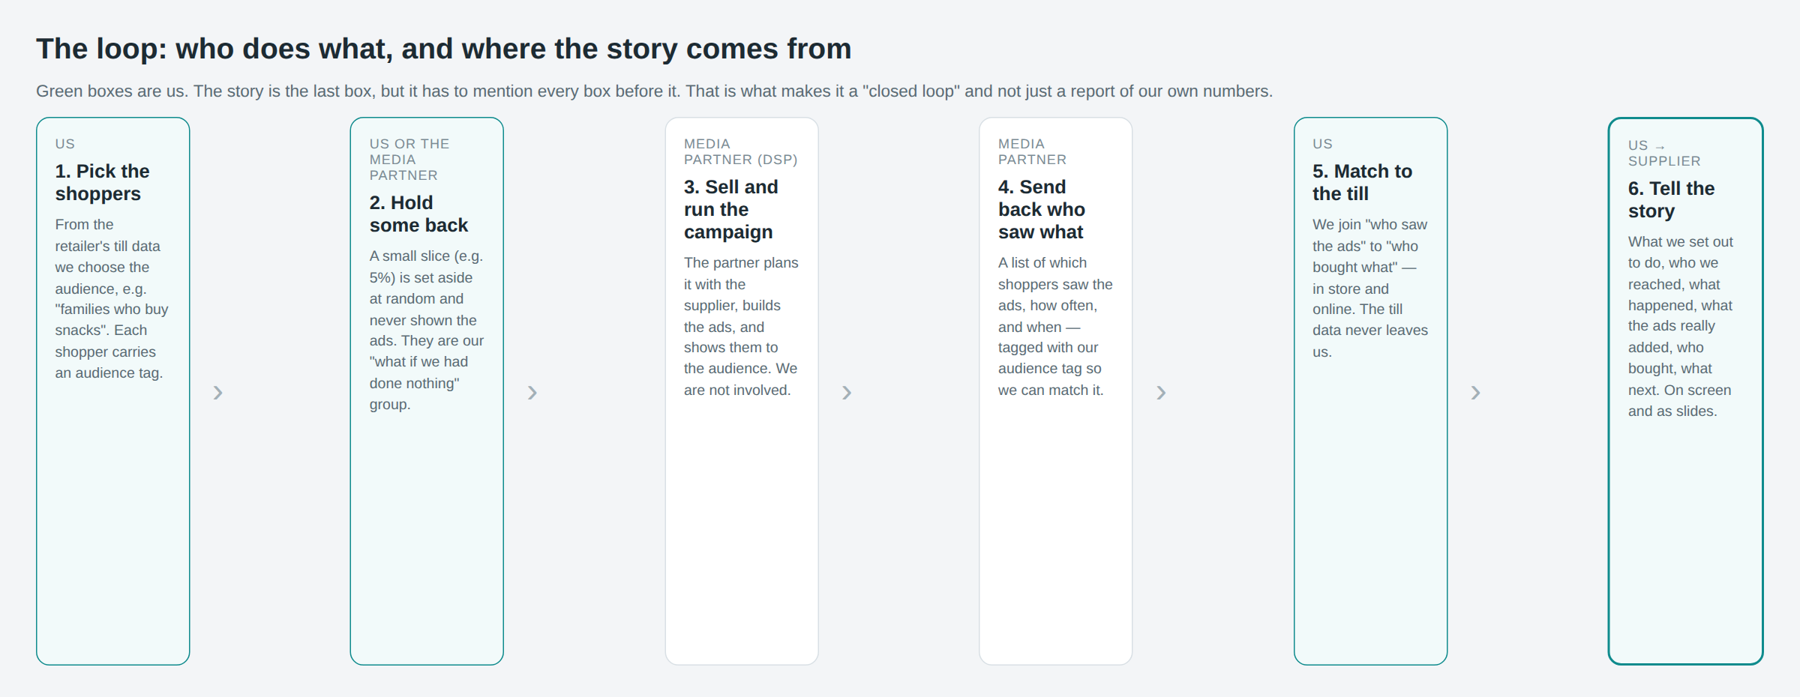

3. What a good campaign story contains
A good story answers four questions, in this order, with the proof attached: Did it sell? Was it the ads? Who bought? What next? Here is how that becomes seven pages.
Page | The question it answers | What is on it
1. What we set out to do | What was the plan? | Goal, dates, budget, products, audience and its size, how many were held back, the counting window.
2. Who we reached | How many shoppers did we actually get to? | A funnel: chosen → held back → reachable → saw an ad → bought.
3. What the ads delivered | Did the ads run as planned? | Ads shown, ads actually seen, clicks, how often each shopper saw one. These are the media partner's numbers; we say so.
4. What happened, day by day | What did sales look like before, during and after? | One line for shoppers who saw the ads, one for shoppers held back. Marks for promotions, stock-outs and ad changes. This is the page the sample deck was built around.
5. What was bought | How much was sold after the ads? | Sales, units, orders, sales per euro. Split: advertised product vs rest of the brand; online vs in store; from clicks vs from views. The counting window printed on the number, with the 30-day figure beside it.
6. What the ads really added | Would it have sold anyway? | Extra sales caused by the ads, with a range ("between 9% and 15%"), extra sales per euro, how we know, how many shoppers in each group.
7. Who bought, and what next | Who did we win, and what should we do? | New buyers of the brand (and how "new" is defined), repeat buyers, top products, three concrete suggestions for the next campaign.
Every page also carries a small How we measured note: which rulebook we follow, the counting window, whether sales are before or after returns, what "same brand" includes, what "new buyer" means, how the held-back group was chosen, and what share of shoppers we could match to the till. This one note is the best answer to "we cannot compare retailers".

4. What others do: Europe
No European retailer publishes a real end-of-campaign report. The cards below are drawn from what each company says on its own website, in help pages, in audit announcements and in case studies (links at the end). Everywhere the pattern is the same: a screen for media numbers and sales, and a separate document for "what the ads really added", usually for bigger campaigns and sometimes at extra cost.
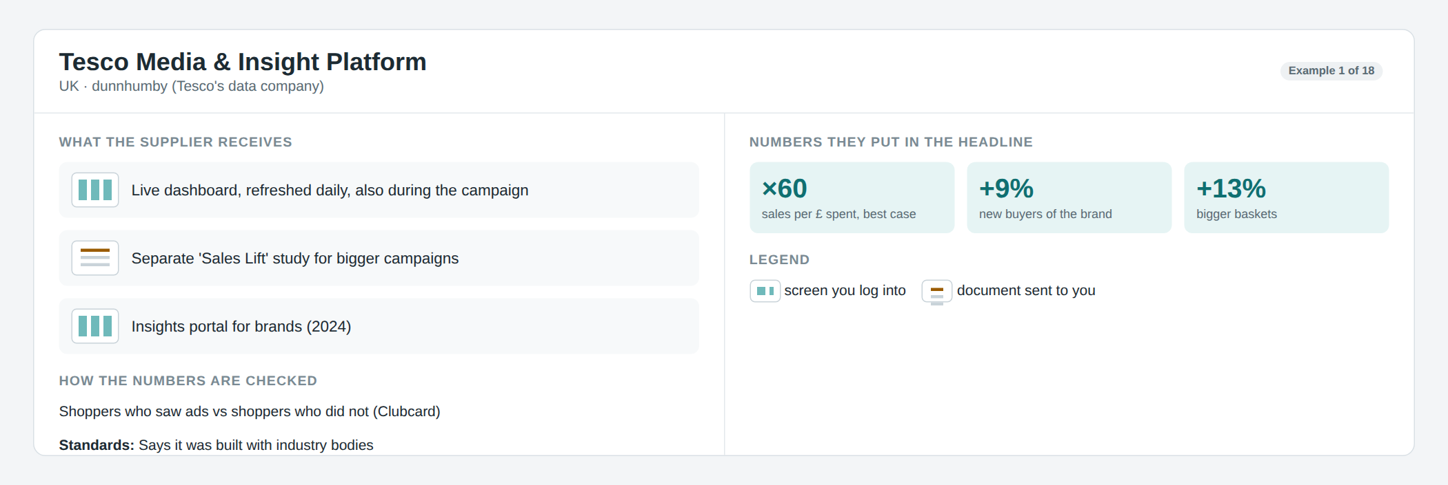
Tesco is the most complete. Brands get a live screen refreshed every day, and a separate "Sales Lift" study that compares shoppers who saw the ads with shoppers who did not, using Clubcard data. The public case study leads with "sales per pound" and "new buyers of the brand".
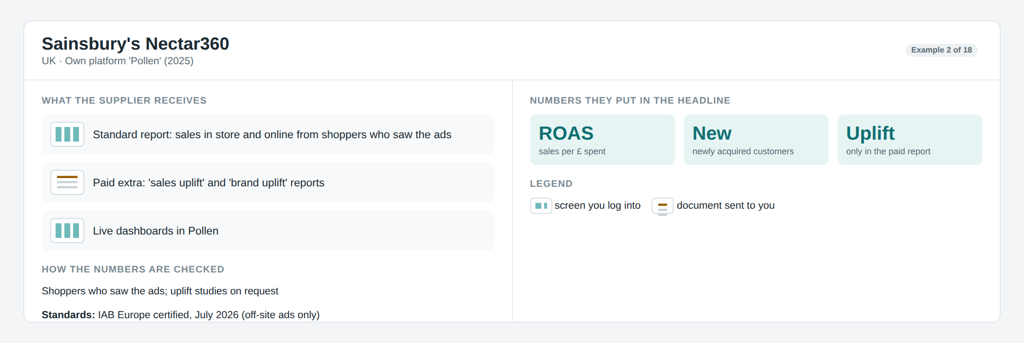
Sainsbury's gives a standard report of sales from shoppers who saw the ads, in store and online. The "was it the ads?" report is a paid extra. In July 2026 it became the first UK retailer audited against the IAB Europe rules, but only for its off-site ads (Meta, Google).
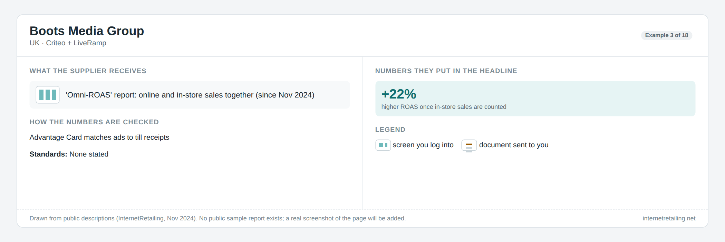
Boots added in-store sales to its report in November 2024. Its headline number is the difference that makes: sales per pound looked 22% better once the till was counted.
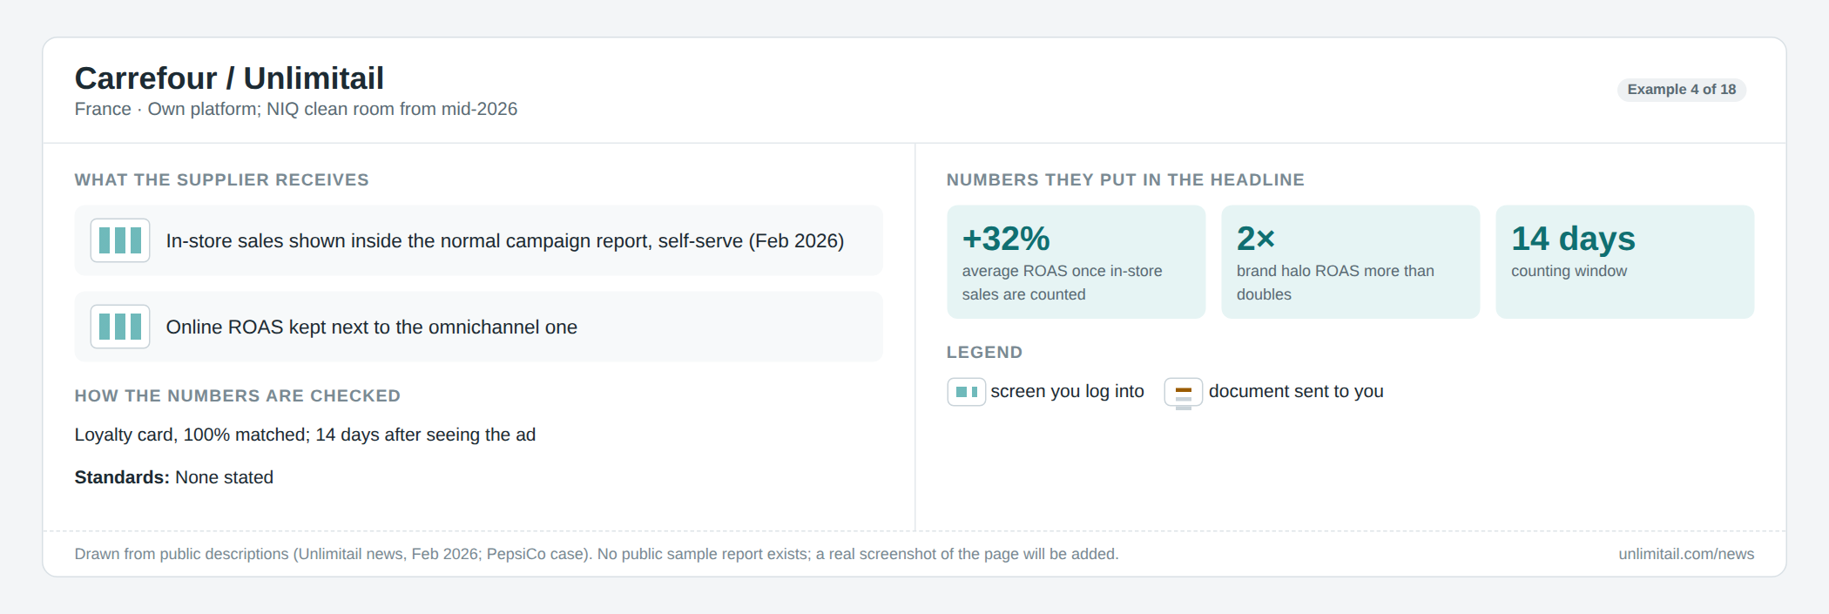
Carrefour's media arm put in-store sales straight into the normal self-serve report in February 2026, with a 14-day counting window. It keeps the old online-only number next to the new one so the difference is visible. Its case studies tell the campaign as a three-part story: awareness, purchase, loyalty.
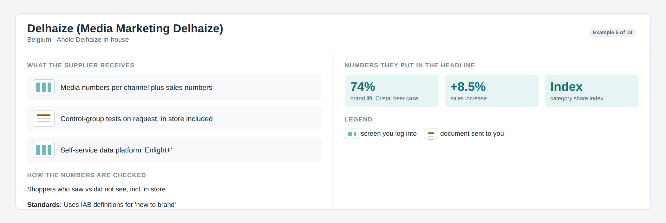
Delhaize in Belgium shows media numbers per channel plus sales numbers, and runs "saw vs did not see" tests including in store. It uses the IAB definition of "new buyer".
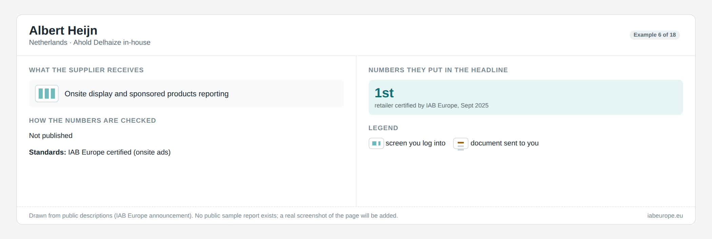
Albert Heijn was the first retailer in Europe audited against the IAB Europe rules (September 2025). It does not publish what its report looks like.
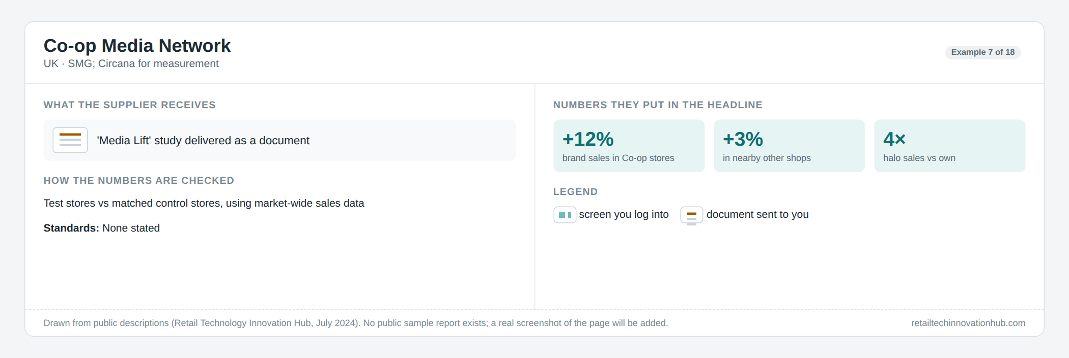
Co-op's "was it the ads?" study is done by Circana using whole-market sales data: shops that showed the ads against similar shops that did not. It reports uplift in Co-op shops and, unusually, in nearby competitor shops too.
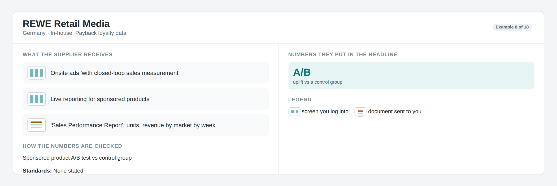
REWE in Germany sells onsite ads "with closed-loop sales measurement" and reports uplift against a held-back group for sponsored products. It also offers a weekly sales performance report by market.
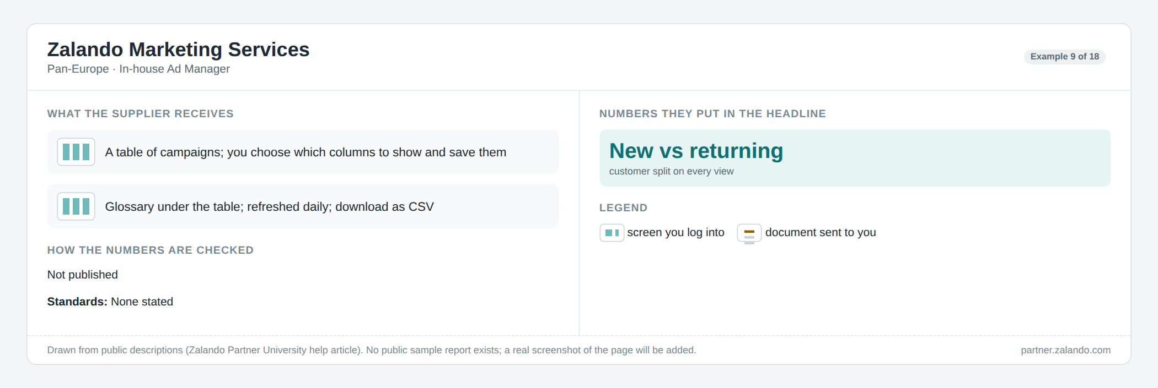
Zalando is the only European company that describes its report screen in detail. It is a table: you choose which columns to show, save them, and download. Every view splits new and returning customers. It is a good dashboard, not a story.
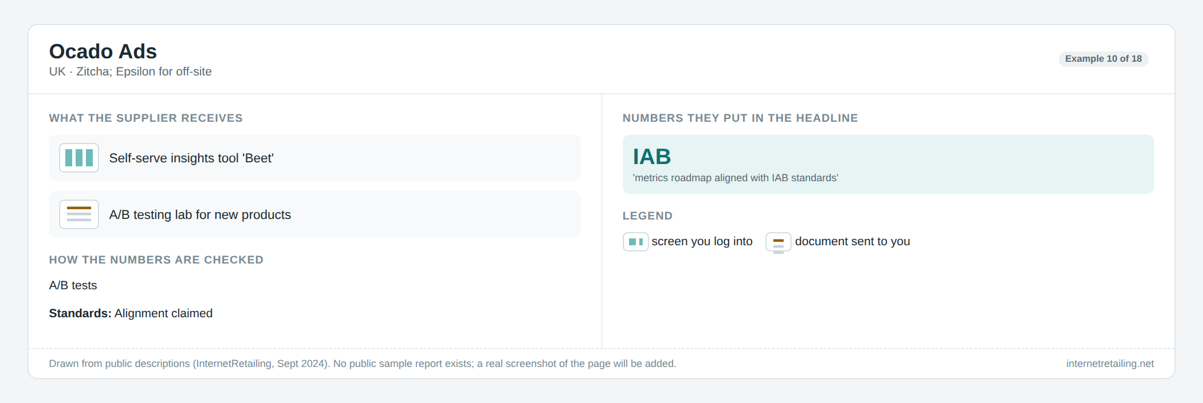
Ocado runs a self-serve insights tool and a testing lab for new products, and says its numbers follow IAB rules.
What this means for us. (1) The "in-store difference" is the European headline; our till data gives it to us for free, so it should be its own page. (2) "Was it the ads?" is sold as a study everywhere; nobody offers it self-serve, so making it a standard page is a real difference. (3) The only public "pick your own" report in Europe is a table of columns. Nobody has a story builder.
Not found in public: Lidl/Kaufland (Schwarz), Leclerc, Casino, Metro, dm, Rossmann, Migros, Coop Switzerland, ICA, Amazon Europe. The Mars United report card for Europe (21 networks, 7 countries) is behind a form.

5. What others do: the US, and the software companies
The US confirms the two-level pattern and gives us the names our prospects will compare us with. Everyone has a self-serve screen for sponsored search, and a separate "sales lift" or "campaign insights" document for in-store and "was it the ads?" results, usually only above a spend minimum.
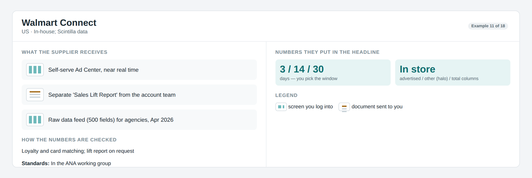
Walmart lets advertisers pick a 3, 14 or 30-day counting window and splits in-store sales into "the advertised product" and "the rest of the brand". The "was it the ads?" result comes in a separate Sales Lift Report. Since April 2026 it also hands agencies a raw data feed so they can build their own decks.
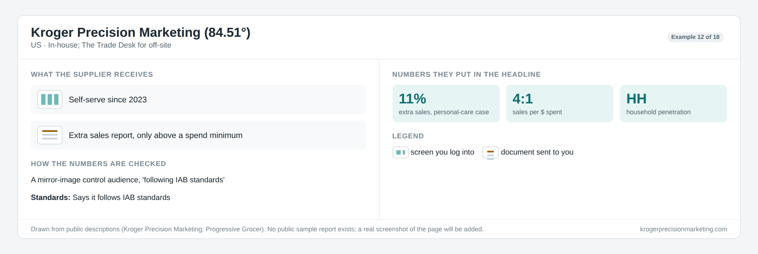
Kroger (84.51°) mirrors the audience to build a held-back group and says it follows IAB rules. The result comes as total sales, extra sales, household reach, units and visits, but only for campaigns above a spend minimum.
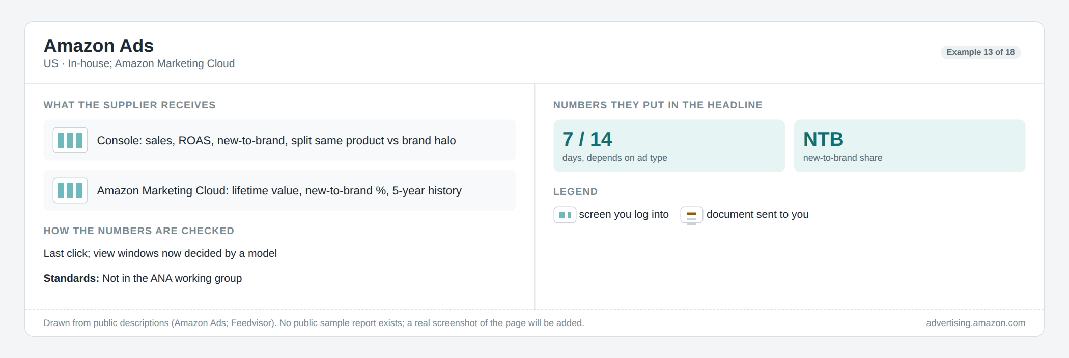
Amazon's console shows sales per dollar, split "same product" and "rest of the brand", and the share of new buyers. Its Marketing Cloud adds lifetime value and a five-year history. Counting windows differ by ad type, which makes numbers hard to compare even inside Amazon.
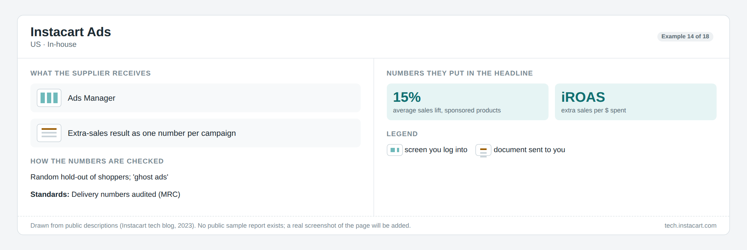
Instacart holds shoppers back at random and publishes its method. The result is a single lift number and "extra sales per dollar"; it does not publish how sure it is.
[image: Albertsons Media Collective]
Albertsons measures in-store campaigns by comparing shops with the ads to similar shops without. Its case for Mondelez: 14% more sales, $2.41 extra per dollar.
[image: Criteo]
Criteo (the software behind Boots and many others) is the most open about how it counts. Its help pages list every number and rule: 7, 14 or 30-day windows, "new buyer" = no purchase in 180 days, three levels of "same product / same aisle / same brand". Its reports are tables you build yourself and email on a schedule.
[image: Zitcha]
Zitcha (the software behind Ocado) is the one company using our prospects' words: its "Report Interpreter" lets you ask a question in plain language and "get answers, not dashboards".
[image: Generic report tools]
Generic reporting tools show what "pick pages and export" looks like as a product: a set of pages, templates per audience, export to PowerPoint or PDF, and a computer-written summary. They cost a few hundred dollars a month and know nothing about retail media.
What this adds. Everyone shows "extra sales" as a single number with no range; showing a range is both what the 2025 IAB guidance asks for and a visible difference. "New buyer" is defined three different ways (Criteo 180 days, IAB Europe by purchase cycle, US advertisers 52 weeks), so we must print our definition. The US recommends a 14-day window while Europe defaults to 30, which our "one window per client, others on request" rule already covers.

6. The rules we must follow
Three rulebooks matter: the European standard (IAB Europe, version 2.1 from May 2026, required for audit since August 2026), the US guidelines (IAB and MRC, January 2024), and the joint guidance on proving that ads caused extra sales (November 2025). None of them says how a report should look. All of them say what a report must state. That list is our "How we measured" note.
The report must… | Required or advised | Which rule
Count an ad as shown only when it actually started to appear, and as "seen" only if half of it was on screen for a second (two for video). | Required | IAB Europe; IAB/MRC
Remove fake traffic and say what share was removed. If sales numbers were not cleaned of fake traffic, label them. | Required | IAB/MRC; IAB Europe
Use a 30-day counting window as the default, and say which window is used, before the campaign and on the results. | Required (Europe default; US: disclose) | IAB Europe; IAB/MRC
Show sales from clicks and sales from views as two separate numbers. | Advised | IAB Europe
Say what "rest of the brand" means: same brand, same category as the retailer defines it. Show it apart from the advertised product. | Advised | IAB Europe; IAB/MRC
Say whether sales are before or after returns. | Required (2026) | IAB Europe V2
If some sales are estimated (cash buyers, unmatched shoppers), say which numbers, how, and what share is estimated. | Required | IAB/MRC; IAB Europe
Say how "new buyer" is defined and over what period. | Advised | IAB Europe; ANA
If claiming the ads caused extra sales: say the method, how the held-back group was chosen, how long the test ran, and its limits. Give a range, and be clear when the range includes zero. | Required (method); advised (range) | IAB/MRC; IAB + IAB Europe 2025
Say who did the audit, if any, and exactly which ad types it covers. | Advised | IAB Europe certification
Audit. IAB Europe runs an audit programme: an independent auditor checks that your definitions and disclosures follow the rules, for the whole network or for named ad types. It costs €7,500 for a retailer plus the auditor's fee. Two retailers have passed so far. The badge says "we count the way the standard says", not "our result is right". This matches our earlier decision: following the rules is non-negotiable in the product; getting the badge is a commercial decision.
Where the rules disagree. US advertisers (ANA, August 2026) want a 14-day window and a 52-week "new buyer" definition; Europe uses 30 days and purchase-cycle bands. A new European draft for in-store ads (open for comment until October 2026) uses 28 days. Our report needs to label windows when two different ones appear on the same page.

7. What we learned across all of them
Pages that always appear, in this order: a headline sentence that says whether it worked; the plan; what the ads delivered against plan; what was sold, with the in-store split; what the ads really added; who bought; three to five named suggestions for next time.
Rank | Number | Who leads with it | What it means for our story
1 | Sales per euro spent, increasingly "with in-store included" | Everyone; Boots, Carrefour, Epsilon lead with the in-store difference | Always print the window; show click and view separately
2 | Extra sales the ads caused, and extra sales per euro | Tesco, Delhaize, Co-op, Kroger, Albertsons, Instacart, DoorDash | Print the method, group sizes and a range
3 | New buyers of the brand | Tesco (+9%), Delhaize, Amazon, Zitcha, Criteo | Print the definition
4 | Rest-of-brand sales | Carrefour, Epsilon, Walmart, Criteo | Same brand, same aisle by the rules; label anything wider
5 | Household reach, category share, basket size | Kroger, Albertsons, Delhaize, Tesco | We can show these from the till alone, from day one
6 | Reach, frequency, ads actually seen | Delhaize, Amazon, Sainsbury's audit | The media partner's numbers; we say where they come from
7 | Lifetime value of the buyers won | Amazon, Chewy, Flywheel | Later
Pictures that recur: a sales line over time with the campaign period shaded and notes on it; "saw the ads" vs "held back" as two bars with a range; plan vs actual bars; a funnel from chosen to bought; a ranked list of top products or ad designs; a small online vs in-store split.
Things the experts tell people to remove: walls of numbers (keep a core report to 15–20 numbers; ours should show about twelve of our 81), speedometer gauges (our current prototype has one on the story page; a bar with a range says more), pie charts, any "sales per euro" shown without its counting window, and "extra sales" claims based on guesses rather than a held-back group.
Two shifts to design for now: reports are becoming live ("what should we change right now", not "did it work"), and summaries are being written by the computer. Both point to a story that builds itself during the campaign.

8. Four ways we could build it
All four share one foundation: a set of ready-made pages. Each page answers one question, shows one picture, starts with one plain sentence, and carries its "how we measured" note. Pages are grouped by what data they need: pages that only need the till and the audience work from our first release; pages that need the media partner's "who saw what" data come in the second and third. A page whose data is not in yet shows as grey with a reason, so the story is never blank. Every page exports as one slide.
Page | Picture on it | Data needed | Ready in release
What we set out to do | A fact box | Registration | 1
Who we reached | Funnel: chosen → held back → reachable → saw an ad → bought | Till + audience (the "saw an ad" step needs the partner) | 1, completed in 2
What the ads delivered | Plan vs actual bars | Media partner | 2
What happened, day by day | Sales line, saw vs held back, before/during/after | Till + audience | 1
What was bought | Sales, units, sales per euro; product vs brand; online vs store; click vs view | Media partner + till | 2
In store vs online only | Two bars: sales per euro online only vs everything | Media partner + till | 2
What the ads really added | Two bars with a range; extra sales per euro | Model on top of the above | 3 (a simple version possible in 1)
Who bought | New vs returning; repeat; basket | Till + audience | 1
Top products / top ad designs | Ranked bars | Till (products); partner (ad designs) | 1 / 2
What to do next | Three suggestions | Written from the pages above | 1
How we measured | The note | All | 1

Concept A — The fixed story
[image: Seven pages, always in the same order. One click makes seven slides.]
Good: fastest to build; every client gets the same story; easiest for an auditor to read. Not so good: a supplier who only wants two pages for their board gets seven; the account manager has no room to shape it.

Concept B — The story composer
[image: Pick pages from a fixed set, reorder them, reword the headline. Numbers and notes are locked. Export to PowerPoint or PDF.]
Good: it is exactly what our prospects do by hand today; works for both self-serve and managed clients; a saved layout becomes the client's template. Not so good: more screens to build; someone could compose a flattering story, which the locked note on every page limits.

Concept C — The four-question brief
[image: Did it sell? Was it the ads? Who bought? What next? Plus "how we measured". Five slides.]
Good: it speaks the buyer's language; perfect as the first page or the executive summary. Not so good: too thin on its own; the day-by-day line and the funnel get squeezed out.

Concept D — The living story
[image: The story grows as the campaign moves from "registered" to "final result". Pages not ready yet are grey with a reason. Export a snapshot at any time, stamped "so far".]
Good: it is literally "the story from beginning to end"; it matches where the market is going (live, not after the fact); and it matches our release plan, because an early release simply means fewer steps light up. Not so good: more logic to build; "so far" numbers must be clearly marked so nobody forwards them as final.
Concept | Effort | Fits "not a dashboard" | Fits the rules | Fits our releases | Main risk
A Fixed story | Low | High | High | Good | Too rigid
B Composer | High | High | High if notes are locked | Good | Cherry-picking
C Four-question brief | Low | Medium | Medium | Good | Too thin alone
D Living story | Medium–high | Highest | High | Best | "So far" numbers forwarded as final

9. What I recommend, and what I need decided
Build D on top of A, then add C and B. In practice: the set of pages and the fixed seven-page story (A) come first; D's steps decide which pages are lit and how they are labelled; the four-question brief (C) is the story's first page, made from the same pages; the composer (B) comes once two or three clients have shown us which pages they hide and reorder.
Why this order: nobody sells the story, so a fixed one is already a difference; the composer is the only piece with a precedent in generic tools, so it can wait; and our release plan already unlocks the till-only pages first.
How it fits what we already have
- Requirements document: add a "Campaign story" capability: what a page is, the steps, the export, and the rule that numbers and notes cannot be edited.
- The list of 81 numbers: add two columns, "which page" and "which step". Most numbers stay in the explorer; the story shows about twelve.
- The prototype: keep the headline sentence, the "audited" stamp and the greyed-out "attributed" numbers. Replace the gauge with two bars and a range. Add the "in store vs online only" page, the "how we measured" panel, the step rail, and an "Export story" button.
- The delivery plan: report design already starts in release 1; the page set is what makes that concrete, and the grey "not ready" pages let release 1 ship a real story without the media partner's data.
Decisions I need
- ☐ Share the sample PowerPoint the prospects gave you, so the block list can be matched slide by slide and the gaps named.
- ☐ Rule on the story unit: one campaign, or an advertiser initiative that groups several campaigns (this is the open campaign-hierarchy decision; the story needs it before the state model is fixed).
- ☐ Rule on export format: PowerPoint with native editable charts, or PDF first with PowerPoint later.
- ☐ Approve the twelve story KPIs out of the 81, and which block each belongs to.
- ☐ Mock the seven chapters as Release-1 placeholders in the prototype and take it to the first client's media team for reaction.
Still unknown after the research: the exact list of methods IAB Europe accepts for "the ads caused extra sales" (the document could not be opened), what Sainsbury's and Tesco uplift reports look like page by page, and whether any European retailer exports to PowerPoint at all. The first two are worth a direct question to IAB Europe and to our first client's media partner.

10. Where the facts come from
Pages opened on 20 Sep 2026. Standards: IAB Europe Retail Media Measurement Standards V1, Apr 2024 · IAB Europe Commerce Media Measurement Standards V2/V2.1 · IAB Europe V2 public-comment draft, Oct 2025 · IAB/MRC Retail Media Measurement Guidelines, Jan 2024 · IAB and IAB Europe Guidelines for Incremental Measurement in Commerce Media, Nov 2025 · IAB Europe Retail Media Certification Programme · IAB Europe in-store and travel proposals, Sep 2026 (ExchangeWire) · ANA framework, Aug 2026 (P2PI) · ISBA/mediasense UK study, Sep 2026 · IAB Europe committee Q&A on ROAS and incrementality, Nov 2025
Europe: Tesco/dunnhumby one-pager · Tesco Upfront Oct 2024 · LiveRamp Tesco case · Nectar360 offsite tips · Nectar360 Pollen brochure, Nov 2025 · Nectar360 certification, Jul 2026 · Boots closed-loop, Nov 2024 · Unlimitail in-store attribution, Feb 2026 · Unlimitail PepsiCo case · NIQ and Unlimitail, Jun 2026 · Delhaize MMD, Jun 2025 · Albert Heijn certification, Sep 2025 · Co-op and Circana, Jul 2024 · REWE Retail Media portfolio · Zalando Ad Manager reporting · Ocado Ads, Sep 2024 · Valiuz Connect, Feb 2026 · Douglas SPA case · WPP Media NL, Oct 2025 · Semetis, Dec 2025 · MediaSense, Aug 2026 · MediaMarktSaturn in ADZINE, Apr 2026 · Mars United Report Card Europe 1H 2026
US: Amazon Marketing Cloud · AMC measurement expansion, Jan 2025 · Feedvisor on Amazon attribution · Walmart Connect measurement · Walmart Connect results, 2025 · Scintilla Media Data Feed, Apr 2026 · Intentwise on Walmart store attribution · KPM closed-loop · KPM incremental sales (Progressive Grocer) · Roundel Reports · Roundel closed-loop ROAS · Instacart incrementality methodology · Albertsons in-store incrementality, Jan 2026 · DoorDash AAM certification, Sep 2026 · CVS on measurement (Circana), Jul 2026 · Osmos buyer's matrix, Sep 2026 · Skai 2026 State of Retail Media Measurement · The Current on measurement, Apr 2025 · P2PI on Northwestern/Dentsu research, Jan 2026
Vendors and report design: Criteo demand-side metrics · Criteo attribution · Criteo analytics · Epsilon in-store attribution, Mar 2026 · dunnhumby Media Measurement · Circana Media Lift · Zitcha platform · Topsort incrementality docs · Moloco iROAS · Measured FAQ · Pacvue measurement · NIQ on incrementality, 2026 · Mars United Report Card Q2 2026 · Whatagraph AI reporting · TapClicks on reporting tools · Power BI export to PowerPoint · Power BI Copilot narrative · Tableau Pulse insight types · Smart Insights post-campaign structure · Improvado report template · AgencyAnalytics dashboard vs report · storytelling with data: dashboard to story · IBCS Top and Bottom 5 · Stephen Few on gauges and pies · Meta conversion lift (Triple Whale)

